Where’s the Treasure?

Remember the hidden Gold coin

What is this?

This is a memory game made using SENSE HAT emulator and python. We’ll use the joystick and LED Matrix on the SENSE HAT to play this game. The SENSE HAT shows a gold coin and we have to remember where it was and use the joystick to find the hidden treasure.

How to play?

* To start the game, Press Run and watch to see where the yellow dot appears- this is the Treasure!
* Use the arrow keys on the keyboard to move the white dot where we think the treasure is hidden. When we get there, press Enter.
* We’ll see a green dot if you are correct and a red dot if you got it wrong.
* We’ll get 10 tries and then a score out of 10 would be recorded.
* At the end, out total score will be shown on the SENSE HAT.

Resources Used:

* Python3
* Trinket

Code:

from sense_hat import *

from time import sleep

from random import randint

sense = SenseHat()

sense.clear()

# Just return the actions we are interested in

def wait_for_move():

while True:

e = sense.stick.wait_for_event()

if e.action != ACTION_RELEASED:

return e

R = [255, 0, 0] # red

Y = [255, 255, 0] # yellow

G = [0, 255, 0] # green

W = [255, 255, 255] # white

score=0

#Keeping score for 10 rounds.

for turns in range(10):

#Producing random yellow pixels

coinx=randint(0,7)

coiny=randint(0,7)

print(coinx,coiny)

sense.set_pixel(coinx,coiny,Y)

sleep(0.5)

sense.clear(Y)

sleep(1)

x=randint(0,7)

y=randint(0,7)

sense.set_pixel(x,y,W)#x,y are the player's co-ordinates

while True:

e = wait_for_move()#wait until the joystick is moved

if e.direction == DIRECTION_MIDDLE:

#When player finds the treasure then pixel turns green for a second

if x==coinx and y==coiny:

sense.set_pixel(x,y,G)

#Increasing the score.

score+=1

#Failed to find the treasure so pixel turns red for a second

else:

sense.set_pixel(x,y,R)

sleep(1)

sense.clear()

break;

sense.clear()

if e.direction == DIRECTION_UP and y>0:

y=y-1

elif e.direction == DIRECTION_DOWN and y<7:

y=y+1

elif e.direction == DIRECTION_LEFT and x>0:

x=x-1

elif e.direction == DIRECTION_RIGHT and x<7:

x=x+1

sense.set_pixel(x,y,W)#Drawing player at new location according to the directions given.

sense.show_message("You found the treasure "+str(score)+" times.")

print("You found the treasure "+str(score)+" times.")

Screenshot:

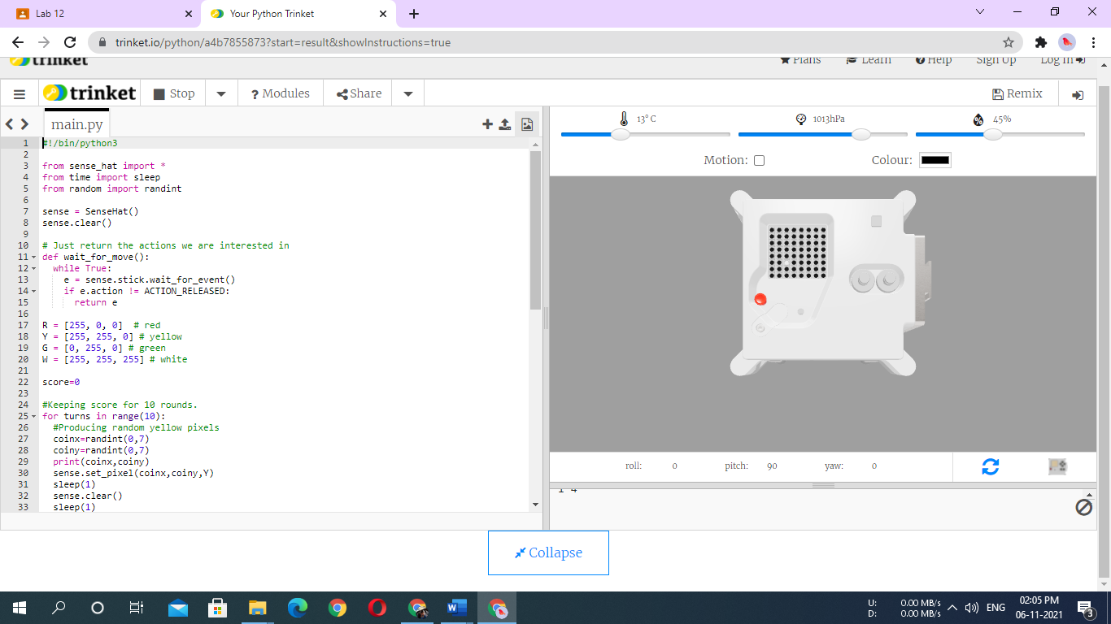

Link for Demo:

https://trinket.io/python/a4b7855873?start=result&showInstructions=true

(Ctrl+click to open the link & see if u can find the treasure!)